**Assignment No 02**



**Name: Furqan Ahmed**

**Reg No: Sp20-bcs-052**

**Submitted To: Muhammad Kamran**

**Date: 17-04-2023**

# Q1: Array functions in JavaScript with examples. Push.

# Solution:

This method adds one or more elements to the end of an array and returns the new length of the array.

const arr = [1, 2, 3];

arr.push(4, 5); console.log(arr);

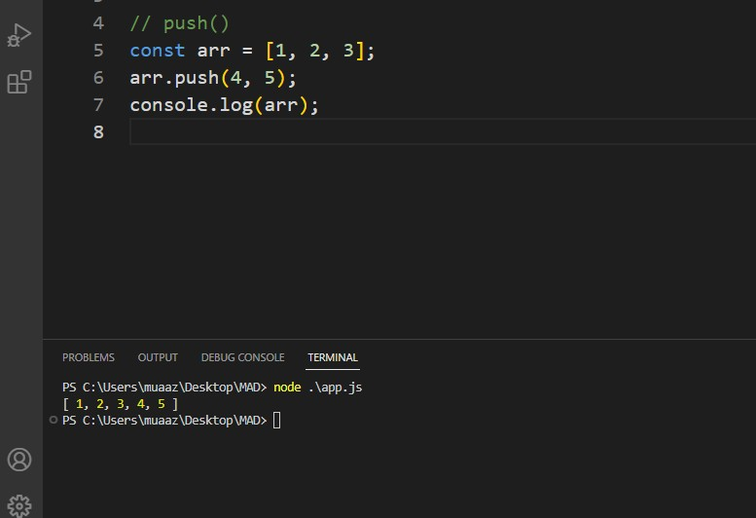

const arr = [1, 2, 3];

const lastElement = arr.pop(); console.log(lastElement); console.log(arr);

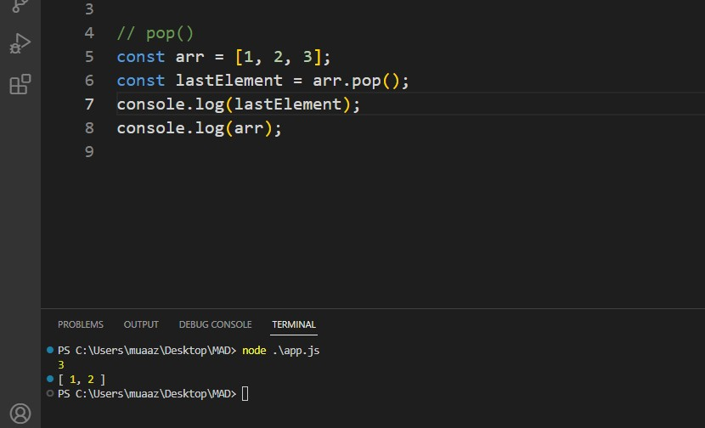

**Shift:**

This method removes the first element from an array and returns that element.

const arr = [1, 2, 3];

const firstElement = arr.shift(); console.log(firstElement); console.log(arr);

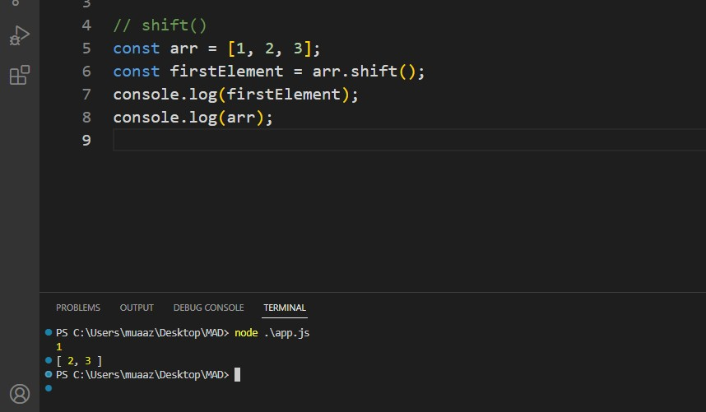

# Unshift:

This method adds one or more elements to the beginning of an array and returns the new length of the array.

const arr = [1, 2, 3];

arr.unshift(0, -1); console.log(arr);

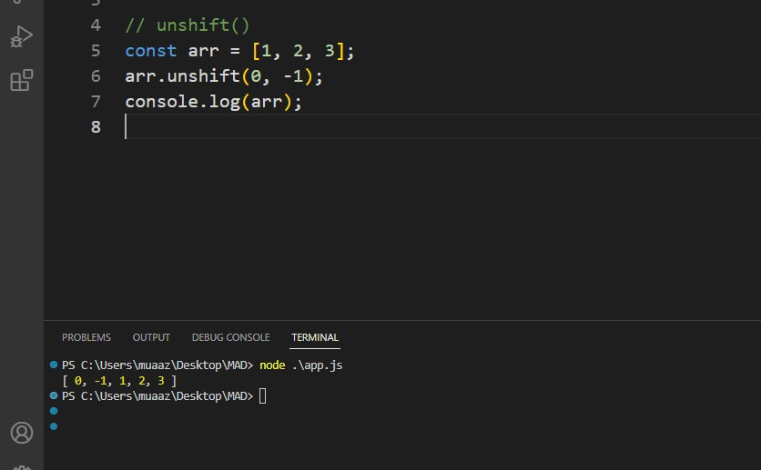

Slice:

This method changes the contents of an array by removing or replacing existing elements and/or adding new elements.

const arr = [1, 2, 3, 4, 5]; arr.splice(2, 1, "a", "b"); console.log(arr);

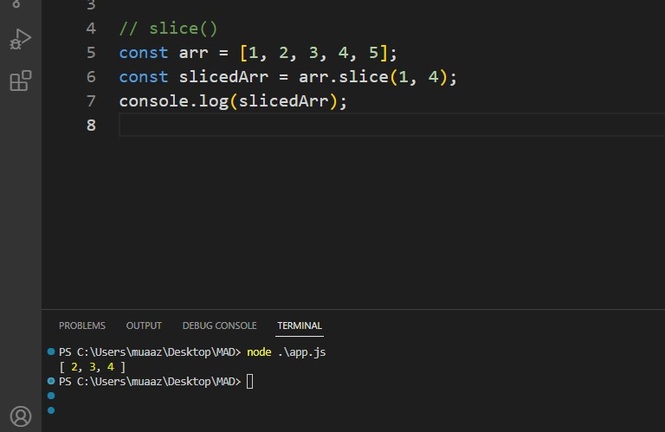

# splice

This method changes the contents of an array by removing or replacing existing elements and/or adding new elements.

const arr = [1, 2, 3, 4, 5]; arr.splice(2, 1, "a", "b"); console.log(arr);

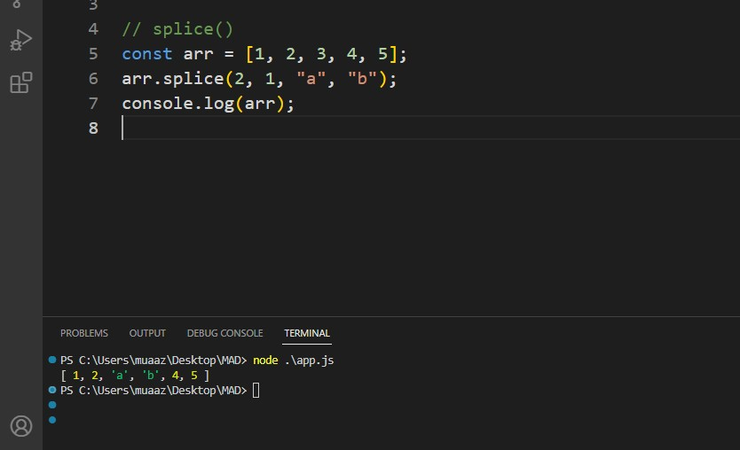

# concat

This method merges two or more arrays into a new array.

const arr1 = [1, 2];

const arr2 = [3, 4];

const arr3 = [5, 6];

const mergedArr = arr1.concat(arr2, arr3); console.log(mergedArr);

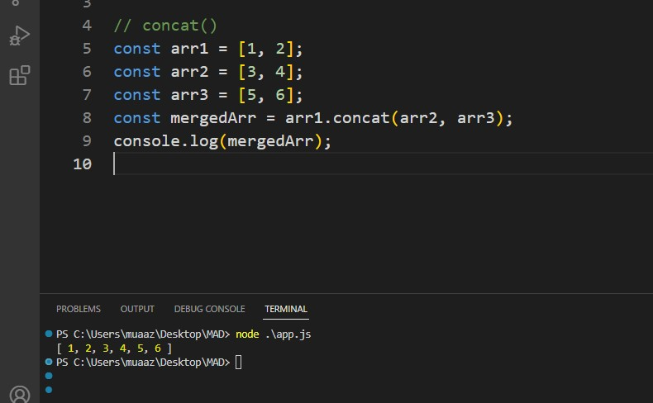

# reverse

This method reverses the order of the elements in an array.

const arr = [1, 2, 3, 4, 5]; arr.reverse(); console.log(arr);

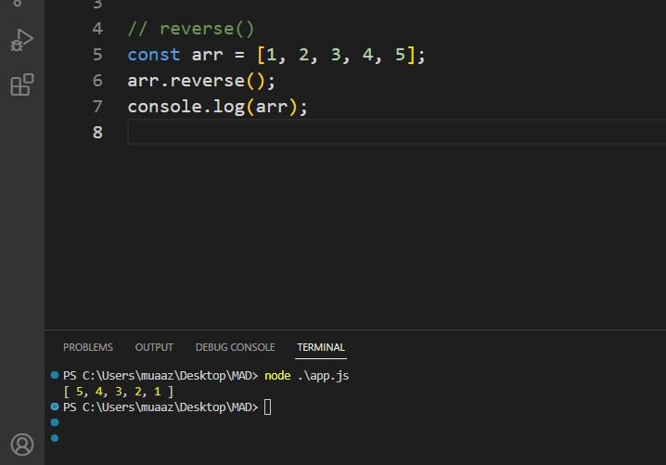

# join

This method joins all elements of an array into a string.

const arr = ["a", "b", "c"]; const str = arr.join("-"); console.log(str);

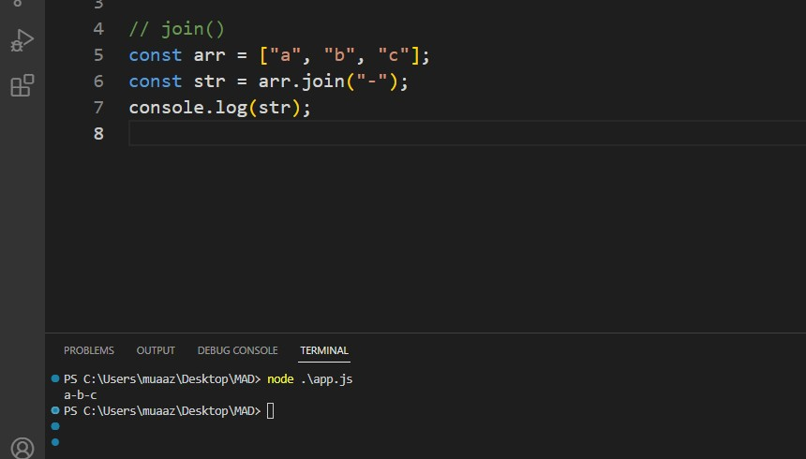

# indexOf

This method returns the first index at which a given element can be found in an array, or -1 if it is not present.

const arr = [1, 2, 3, 4, 5]; const index = arr.indexOf(3); console.log(index);

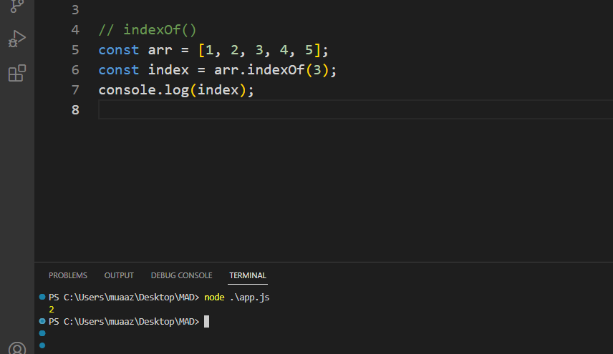

Q2: String functions in JavaScript with example.

# length

This property returns the length of a string.

const str = "Hello, world!"; const length = str.length; console.log(length);

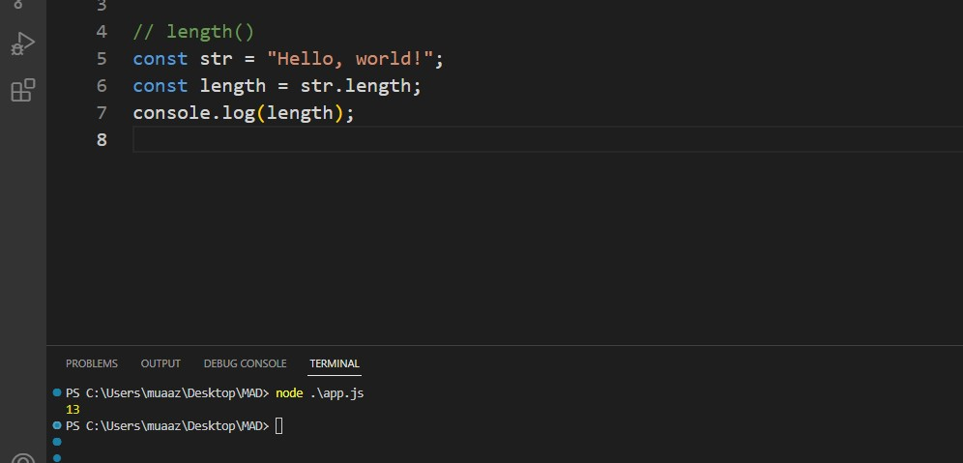

# charAt

This method returns the character at a specified index in a string.

const str = "Hello, world!"; const char = str.charAt(1); console.log(char);

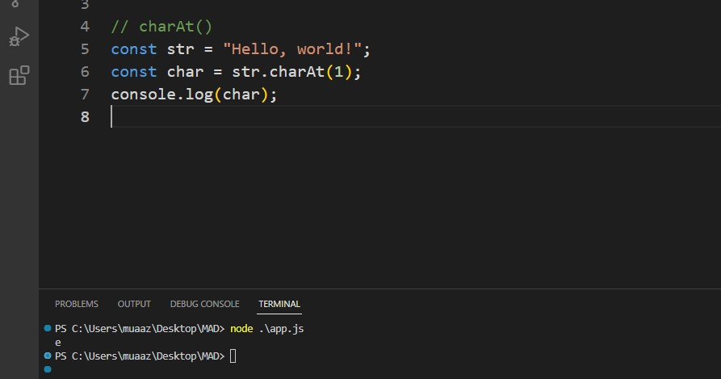

# concat

This method concatenates two or more strings and returns the new string.

const str1 = "Hello, "; const str2 = "world!";

const newStr = str1.concat(str2); console.log(newStr);

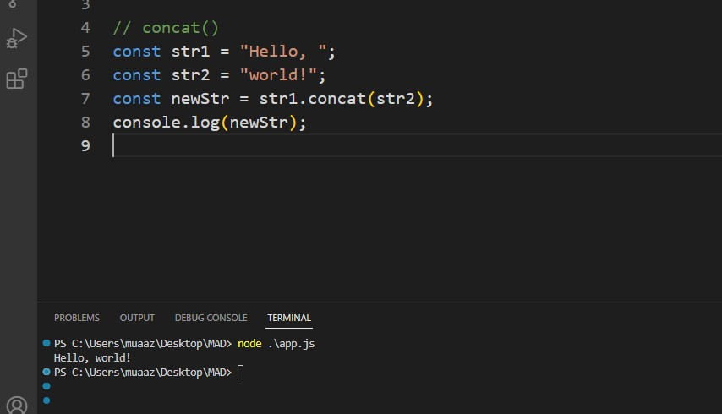

# slice

This method returns a portion of a string into a new string.

const str = "Hello, world!"; const newStr = str.slice(7, 12); console.log(newStr);

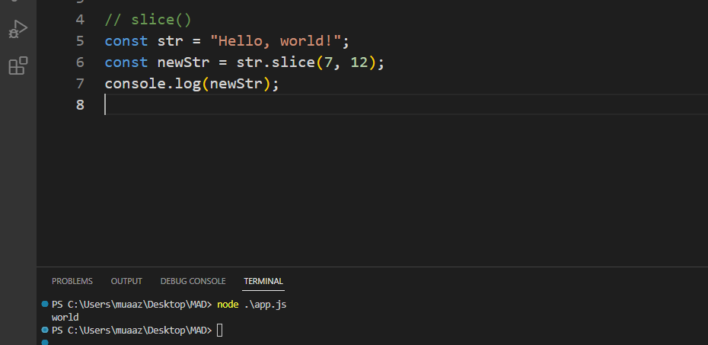

# toLowerCase

This method returns a new string with all characters in lowercase.

const str = "HELLO, WORLD!"; const newStr = str.toLowerCase(); console.log(newStr);

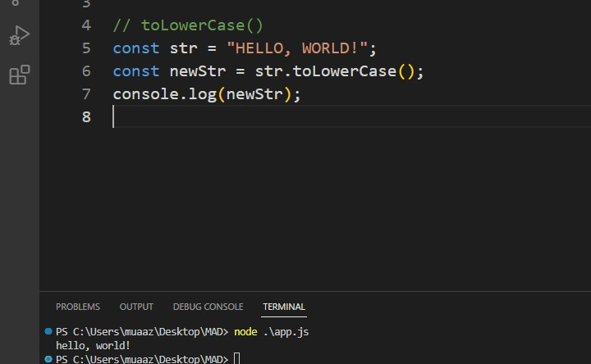

# toUpperCase

This method returns a new string with all characters in uppercase.

const str = "Hello, world!"; const newStr = str.toUpperCase(); console.log(newStr);

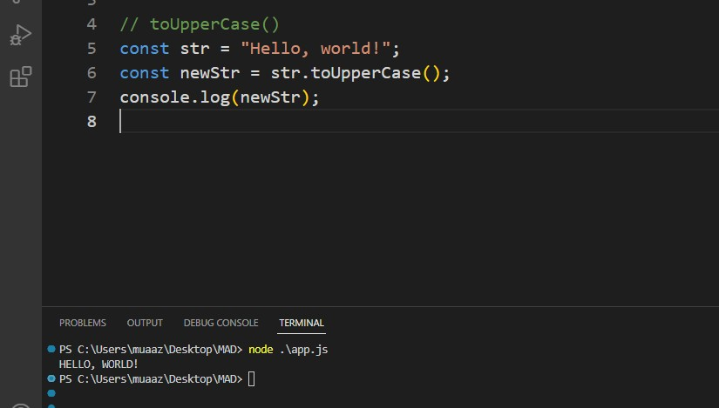

# trim

This method removes whitespace from both ends of a string.

const str = " Hello, world! "; const newStr = str.trim(); console.log(newStr);

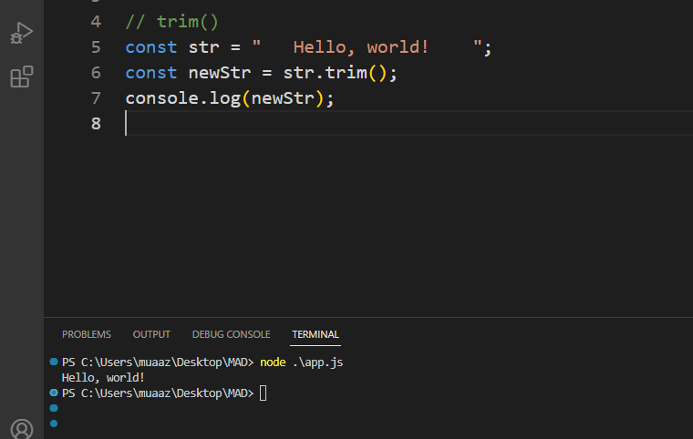

# indexOf

This method returns the index of the first occurrence of a specified value in a string, or -1 if it is not found.

const str = "Hello, world!";

const index = str.indexOf("world"); console.log(index);

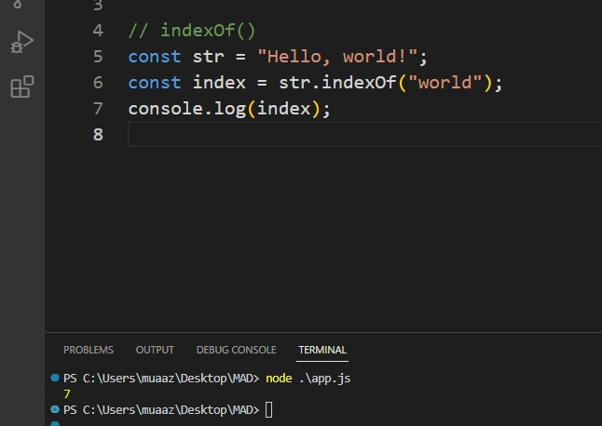

# replace

This method replaces a specified value with another value in a string.

const str = "Hello, world!";

const newStr = str.replace("world", "Universe"); console.log(newStr);

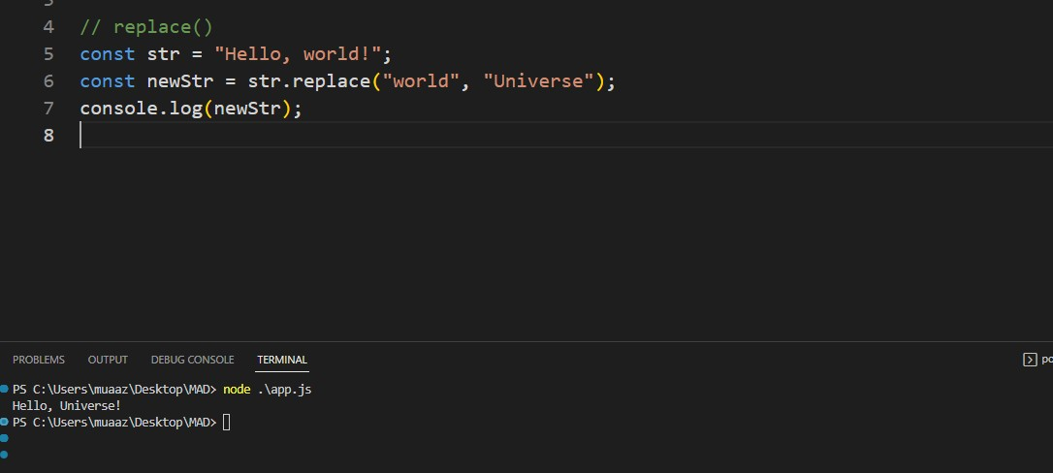

# split

This method splits a string into an array of substrings based on a specified separator.

const str = "Hello, world!"; const arr = str.split(","); console.log(arr);

